Trends, Methods, and Perspectives of Education Curriculum in Indonesia Towards the Quality and Outcomes of Physics Learning Using the Bibliometric Approach

Hanan Zaki Alhusni¹, Akhmad Iswardani¹, Titin Sunarti¹, Hanandita Veda Saphira², Muhammed Akif Kurtuluş³
¹Universitas Negeri Surabaya, Surabaya, Indonesia
²University of Wollongong, Wollongong, Australia
³Alanya Alaaddin Keykubat University, Alanya, Turkey

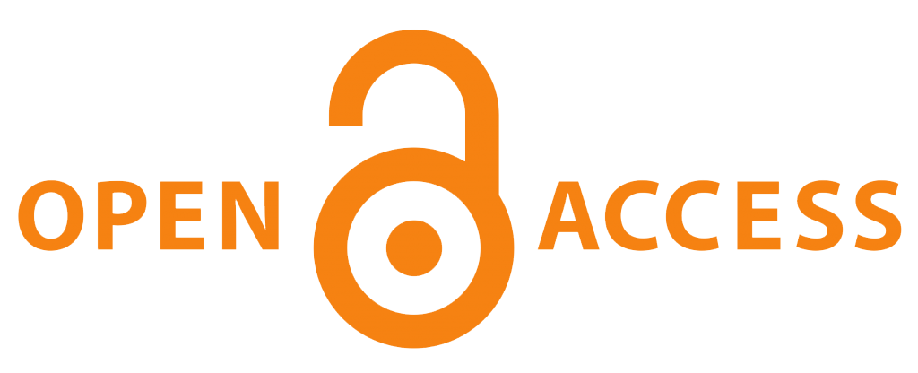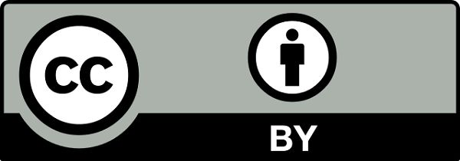 |  | DOI: https://doi.org/10.63230/jolabis.1.1.41
Sections Info |  | ABSTRACT
Article history:  Submitted: May 9, 2025  Final Revised: May 29, 2025  Accepted: May 29, 2025  Published: May 30, 2025 |  | Objective: This study aims to map related keywords and identify research trends concerning the Indonesian physics curriculum, with a focus on quality and learning outcomes, in order to uncover potential directions for future research. It also seeks to provide an overview of research topics that have been most frequently explored, especially those indexed in the Scopus database. Method: This study employed a bibliometric analysis approach using data retrieved from the Scopus database. The analysis focused on publications related to the Indonesian curriculum in physics education from 1977 to 2024. The parameters analyzed included keyword co-occurrence, most productive authors, and frequently targeted journals. Results: The bibliometric analysis identified 287 articles related to the Indonesian curriculum. The most frequently occurring keywords were curriculum, quality education, curriculum development, and curriculum evaluation. The most prolific author in this field was Didi S. Meanwhile, the Journal of Physics: Conference Series appeared as the journal with the most publications related to curriculum and science literacy. These results indicate a continuing interest in curriculum-related research within the scope of physics education in Indonesia. Novelty: This study offers a systematic mapping of Indonesian curriculum research trends in physics education over nearly five decades. It highlights underexplored areas and presents evidence-based insights into future research opportunities, particularly in integrating curriculum studies with physics learning outcomes. The findings contribute to strategic planning for researchers and policymakers aiming to enhance curriculum development in Indonesia.
Keywords:
Bibliometrics;
Curriculum;
Meta Data;
Outcomes;
Quality and Learning.

INTRODUCTION
The curriculum is the heart of any education system, acting as a roadmap that guides the learning process, from determining teaching materials to effective teaching methods (Malik et al., 2015; Suhendi et al., 2018; Astalini et al., 2020). A good curriculum not only ensures uniformity in the quality of education but also ensures that students acquire knowledge, skills, and values ​​relevant to the demands of the times and the needs of society (Sukmawa et al., 2019). A carefully designed curriculum will help students achieve their maximum potential and become productive and responsible citizens.
The education curriculum in Indonesia has undergone significant transformations over time. Since independence, the curriculum has undergone continuous revisions to adapt to developments in the era, global demands, and changes in community needs (Ariyani et al., 2018). The development of this curriculum is marked by a shift in focus from knowledge transmission to competency development, as well as the integration of technology in the learning process. The curriculum also increasingly emphasizes the importance of student-centered learning, with the integration of character values and the strengthening of literacy and numeracy (Gok, 2010; Ariyani et al., 2018).
The education curriculum in Indonesia has undergone several changes, each with distinct characteristics and focuses (Harjono et al., 2016; Handriani et al., 2017; Doyan, 2021). These curricula include the 1984 Curriculum, which emphasizes mastery of the material; the 1994 Curriculum, which is more flexible and provides autonomy to schools; and the 2004 and 2013 Curricula, which are oriented towards competence and character (Lestari, 2011). The advantages of these curricula are efforts to adapt education to the times and the needs of society. However, each curriculum also has disadvantages, such as an overwhelming amount of material that students must master, a lack of available resources, or difficulties in implementation in the field. Curriculum changes that are too frequent can also confuse teachers and students (Ali et al., 2018; Medriati et al., 2020).
The development of the education curriculum in Indonesia has also shaped the face of physics education over time. Since the beginning of independence, physics education has undergone various changes, from a more theoretical approach and memorizing formulas to one that emphasizes understanding concepts and critical thinking skills (Setiawan, 2017). The physics curriculum in Indonesia has undergone several revisions in response in response to the development of science and technology and the changing demands of the times (Setiawan, 2017; Ali et al., 2018). Significant changes are evident in the shift from knowledge transmission to competency development, as well as the integration of technology in physics learning. The current curriculum encourages students to be more active in the learning process, conduct experiments, and connect physics concepts with everyday life.
The educational curriculum has a significant influence on the quality and learning outcomes of students in physics (Ahmad, 2020; Cahyanovianty, 2020). A well-designed, relevant, and up-to-date curriculum can increase students' learning motivation, conceptual understanding, and critical thinking and problem-solving skills (Ahmad, 2020). Conversely, a curriculum that is too dense, less relevant, or less flexible can hinder the learning process and reduce learning outcomes (Ahmad, 2020). Additionally, the quality of curriculum implementation is also crucial. Factors such as teacher competence, availability of facilities and infrastructure, and support from various parties will also determine the success of curriculum implementation and its impact on student learning outcomes (Astuti, 2013; Ahmad, 2020).
However, many national curriculum research in the field of education have been researched and applied. However, this study focuses on analyzing bibliometrics with the topic area of ​​the relationship between curriculum and improving the quality and learning outcomes in physics education. Therefore, this study focuses on mapping related keywords and identifying the trends in Indonesian curriculum research topics, particularly in the field of physics education, to explore potential research opportunities in the future. A comprehensive study is needed to help other researchers plan steps to improve the quality of education.
This article aims to provide a bibliometric analysis of the literature related to the national curriculum in physics education, as well as research trends and publications indexed by the Scopus database from 1977 to 2024. This analysis can reveal the topic areas that are the subject of most publications and research opportunities for the national education curriculum, especially in physics learning.

RESEARCH METHOD
This study employs bibliometric analysis, utilizing the Scopus database. Data collection was conducted on October 31, 2024, using the keyword "Indonesian curriculum in physics on quality and learning outcomes." This study limits the year of publication to 1977-2024. The data obtained is then stored in CSV format. After that, the existing data was analyzed using Vosviewer, Microsoft Excel, and Microsoft Word software to enhance the visualization. According to Prahani et al. (2022), Suprapto et al. (2021), Xie et al. (2020), Lu et al. (2021), and Kulakli and Osmanaj (2020), bibliometric analysis can be used to identify and validate the novelty of current research trends. Figure 1 illustrates the research flow.

Searching for articles in the Scopus database

Limited to 1977-2024 only
Analyzing using Ms-excel, Ms-word, and Vosviewer
Make conclusions based on the results obtained

Figure 1. Research flowchart

RESULTS AND DISCUSSION
Results
Publication Trends
The number of documents obtained from the Scopus database from 1977 to 2024 is shown in the bar chart in Figure 2.
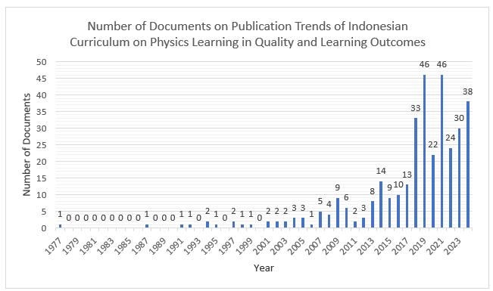
Figure 2. National curriculum publication trend bar chart on physics learning 1977-2024

Figure 2 shows the number of publications of documents in the field of the national curriculum from 1977 to 2024. In 1977, one article was published, and from 1978 to 1986, no further articles were published. Starting in 2000, there was an increase, with the most articles published in 2019 and 2021, which each contained 46 articles. In 2020, the number of documents decreased. This can occur due to the impact of COVID-19, which has implications for the number of publications (Yenny, 2021). In addition, changes in the educational system, which transitioned from face-to-face to virtual, also had an impact on the learning systems. In 2024, there were 38 documents, as the year was still ongoing for 10 months, with 2 months still to run.

Bibliometric Map
The following is a visualization of the database results obtained. For more details, see Figure 3 below.

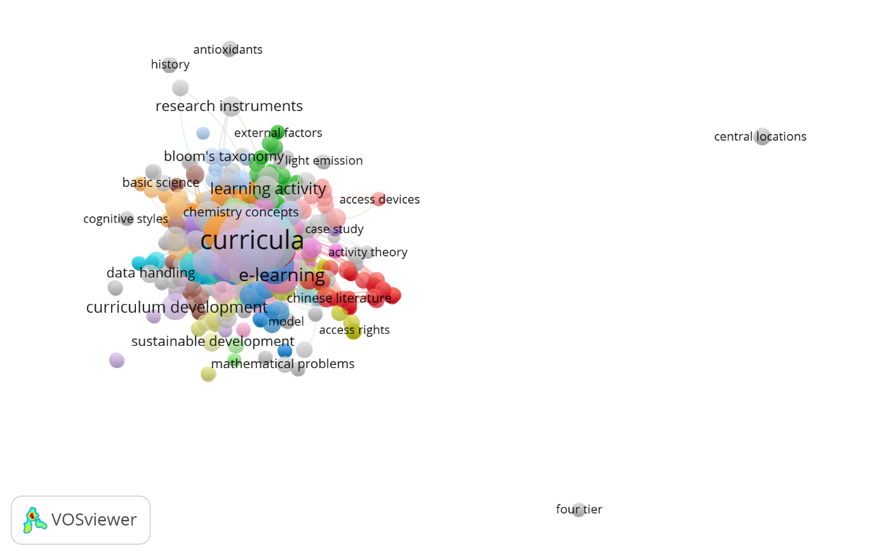
Figure 3. Visualization of Curriculum Distribution

Figure 3 shows the visualization of co-occurrence on a text-based map of the Indonesian curriculum for physics learning. The distribution of bibliometric maps on the topic of the Indonesian curriculum in physics learning consists of four clusters, namely red, yellow, green, and blue. The number of words on the distribution of the bibliometric map obtained is 788 words. Each word is connected by a network that shows the relevance of the keyword to the curriculum topic. Each color is also interrelated, depending on its relationship. The larger the circle, the more text data or words are used in the context of the curriculum. Thus, the curriculum has a very close relationship with the various words above.
Next, in the yellow cluster, there is the keyword motivation. Motivation for development and research in all fields is crucial, particularly in the realm of education. In addition, the research by Hewi and Indari (2021) discusses the motivation behind the existence of a virtual curriculum during the COVID-19 pandemic era. Research by Hamzah et al. (2020) also discusses the development, specifically regarding the curriculum for motivating children with special needs. The research of Sukmawa et al. (2019) also discusses the development of the curriculum as a motivation for practical performance in physics subjects in high school.
Then, in the green cluster, there are keywords physics teacher, test, and independent learning curriculum. The research results of Malik et al. (2015) discuss the implementation of an independent learning curriculum in LKPD, with a focus on scientific literacy in physics learning. This approach to LKPD assessment is not limited to traditional question models but also utilizes questions that focus on scientific literacy. Several curriculum models are used in learning, such as literacy in the form of LKPD, as researched by Setiawan (2017). Literacy is not only carried out using LKPD but can also be connected to the Facebook application, which will later yield data that differs from literacy in LKPD in general. This finding aligns with Dewi's (2013) research results, which were conducted using the Facebook application. In the blue cluster, there are keywords, namely demand and researcher. There are many curriculum systems for assessment demands on literacy, such as in the research of Malik et al. (2015) discussing the curriculum regarding the analysis of the formative assessment of high school physics based on computer-assisted scientific literacy, wherein the assessment system and tools it turns out that it is also very much needed with the existing developments. Several tools are used in the science literacy assessment curriculum, as seen in Cahyanovianty's (2020) research, which involves developing a self-made practical module to assess science and social literacy process skills. Another tool used is the development of an instrument for authentic assessment, which utilizes students' skills. In this case, it can encourage students to understand better the skills they possess, as seen in Astuti's (2013) research.

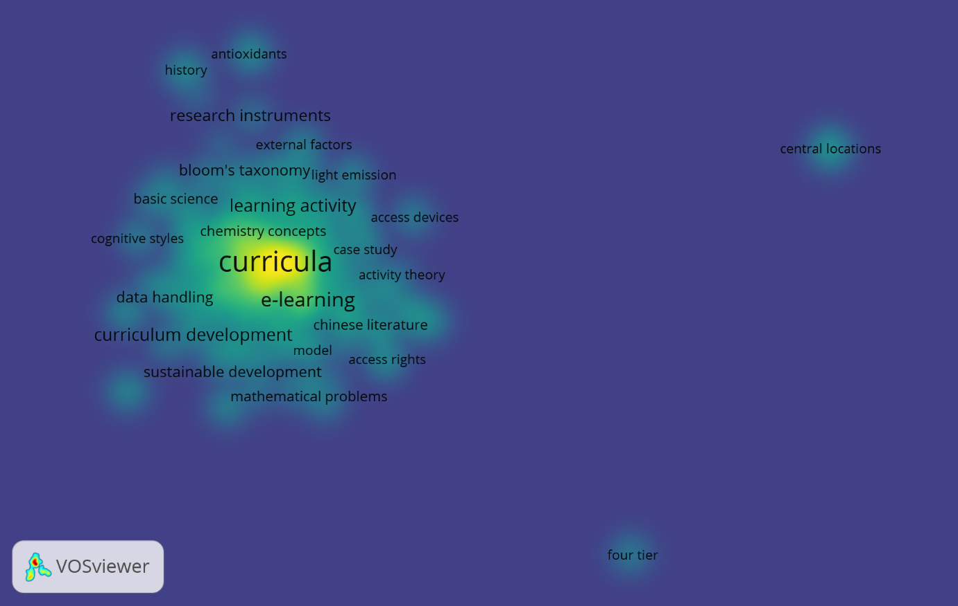
Figure 4. Density visualization of curriculum in physics learning

Figure 4 shows that there are words with bright and dim intensity, as well as larger writing than others. In brighter intensity and larger writing, there are keywords such as test, teaching, license, and physics teacher, while in dim intensity, there are keywords like scientist, n-gain, STEM, time, science, PISA, profile, and many more. From this density visualization, we can identify novelty, specifically in physics teaching and curriculum. This means that words that have a larger density and size are the most frequently used novelty words in curriculum research topics in the field of physics education. In line with the learning process, students are needed as supporters of learning and skills to measure student development.
There are several models for developing curriculum implementation, such as LKPD with specific skills (Setiawan, 2017) representation (Medriati & Risdianto, 2020), projects (Ali et al., 2018), and alternatives (Ahmad, 2020). In the study by Setiawan (2017), which examines the relationship between LKPD and learning motivation, it is found that integrating specific skills into LKPD yields a positive correlation with learning motivation in students. The study (Medriati & Risdianto, 2020) discusses the application of the representation curriculum in physics learning. The results obtained showed that the representation-based curriculum can improve students' mastery of concepts.
The study (Ali et al., 2018) discusses the development carried out using a curriculum in the form of a project. This study comprises three stages: investigation, design, and realization. The study (Ahmad, 2020) discusses the curriculum as an alternative used during an emergency. The alternative curriculum used is in the form of accommodating readings from other countries and assessing the curriculum.

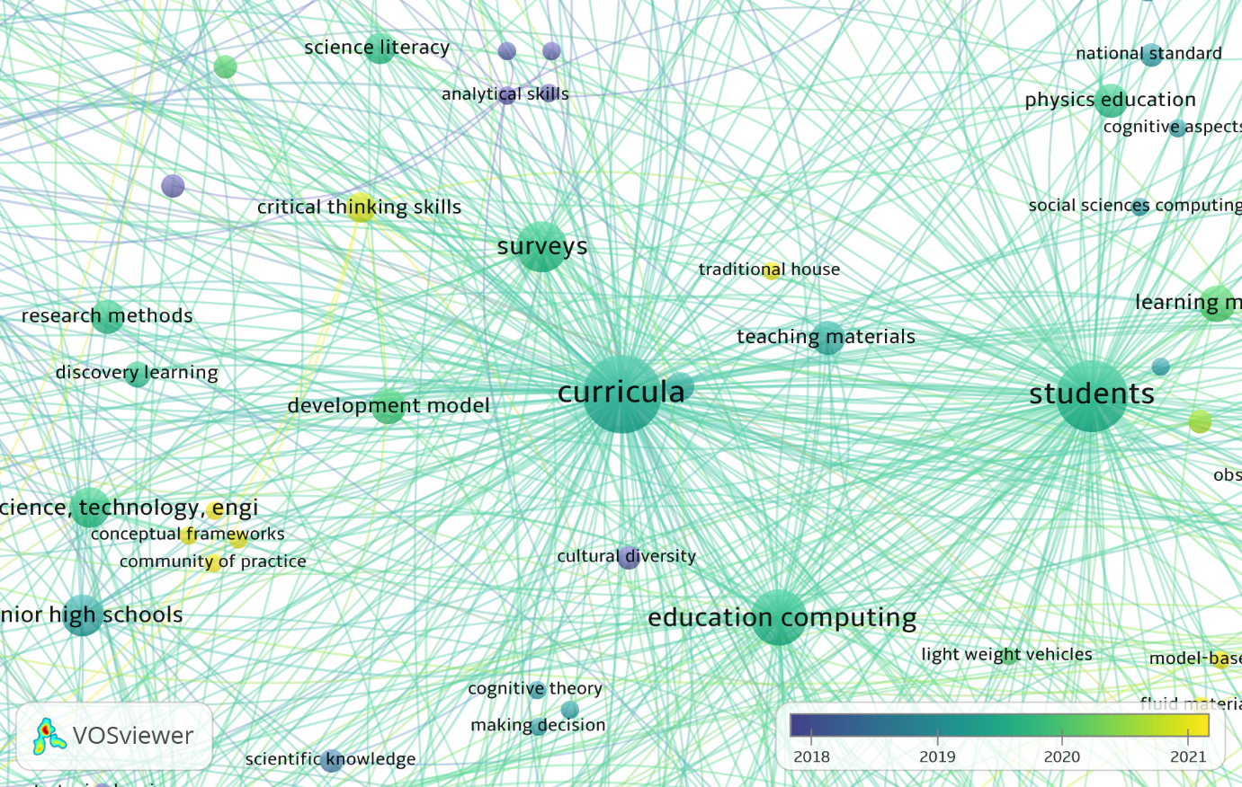
Figure 5. Map network visualization of the keyword “Curricula”
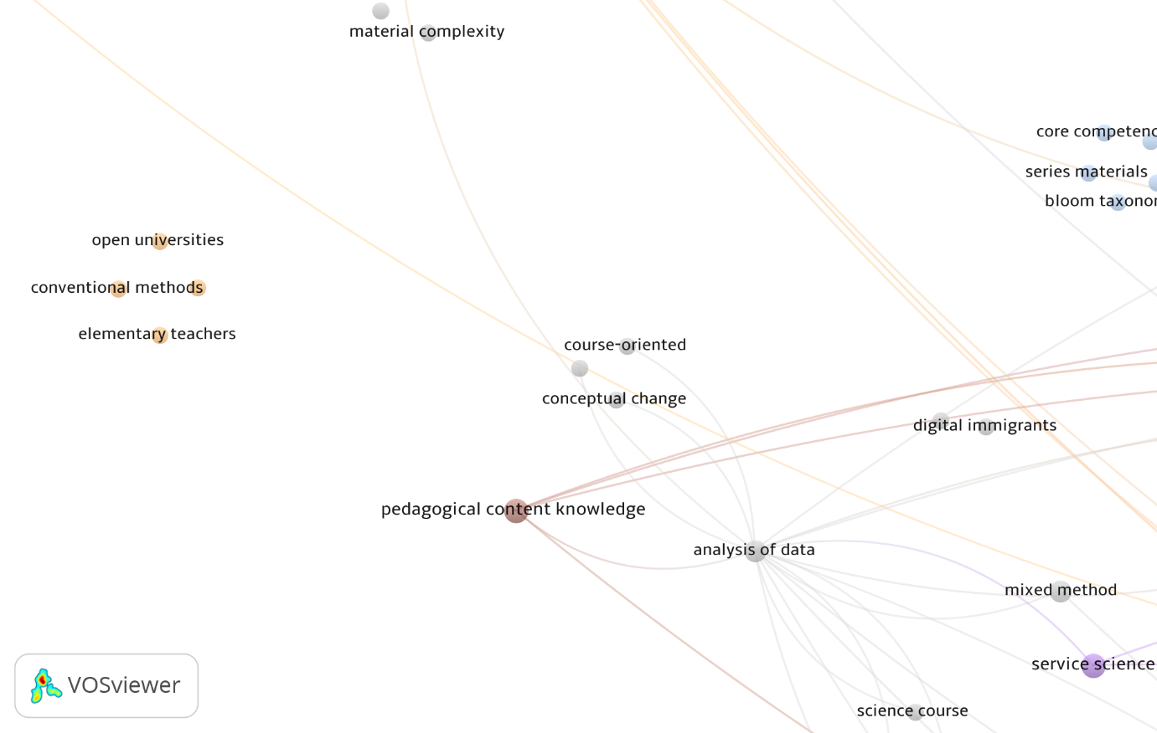
Figure 6. Map network visualization of the keyword “Quality Education”

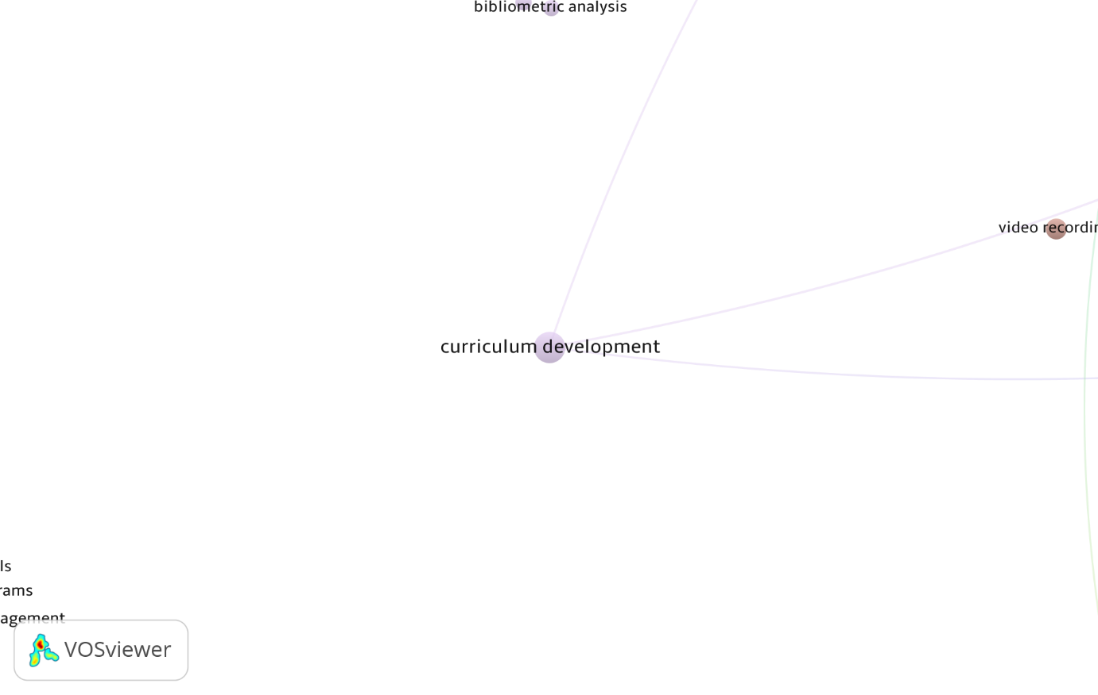
Figure 7. Map network visualization of the keyword “Curriculum Development”
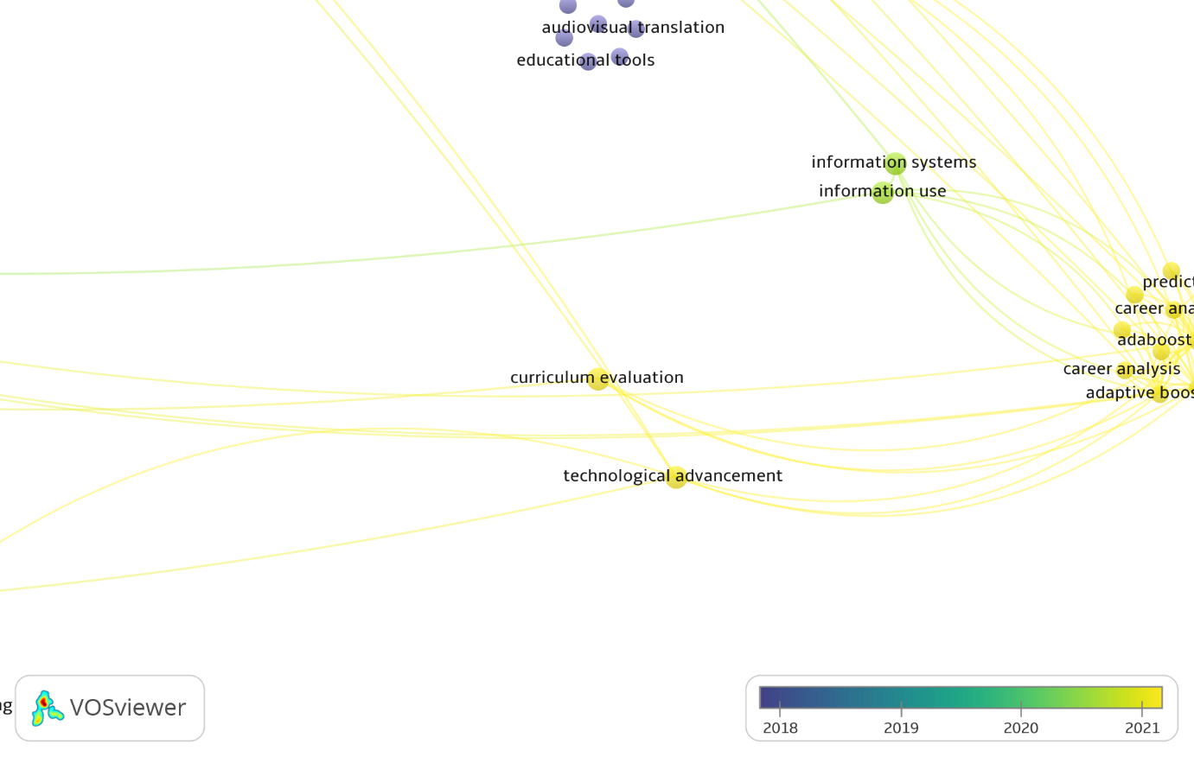
Figure 8. Map network visualization of the keyword “Curriculum Evaluation”

Based on Figures 5, 6, 7, and 8 above, this is a network map visualization of the keywords related to curriculum, quality education, curriculum development, and curriculum evaluation. These four words are among the key concepts closely related to the Indonesian physics curriculum. Each color in the cluster is interconnected. In Figure 5, the word "curriculum" is related to other keywords, such as "high school student," "license," and "society," among others. In Figure 6, the term' quality education' is related to other keywords, such as 'teaching,' 'practice,' and 'observation,' among others. In Figure 7, the term "curriculum development" is related to other keywords, such as "nature," "practice," and "test," among others. In Figure 8, the term "curriculum evaluation" is related to other keywords, such as "video recording," etc. From the keywords that have been used, it can be seen that curriculum is very closely related to quality education (Malik et al., 2015b); (Astalini et al., 2020); (Suhendi et al., 2018); (Kane et al., 2016); (Ariyani et al., 2018), and (Gok, 2010). Therefore, a curriculum will develop well when there are skills in each learning. Additionally, the keyword curriculum also significantly influences the learning model employed. This is to the results of research from (Wahyuni ​​& Taufik, 2016) (Handriani, Harjono, and Doyan, 2017); (Lestari, 2011); (Santyasa, Rapi, and Sara, 2020); and (Krasnova & Shurygin, 2019) stated that by adjusting certain methods to each specific skill-based learning material, it will produce good results.

Author on National Curriculum Topic on Physics Learning

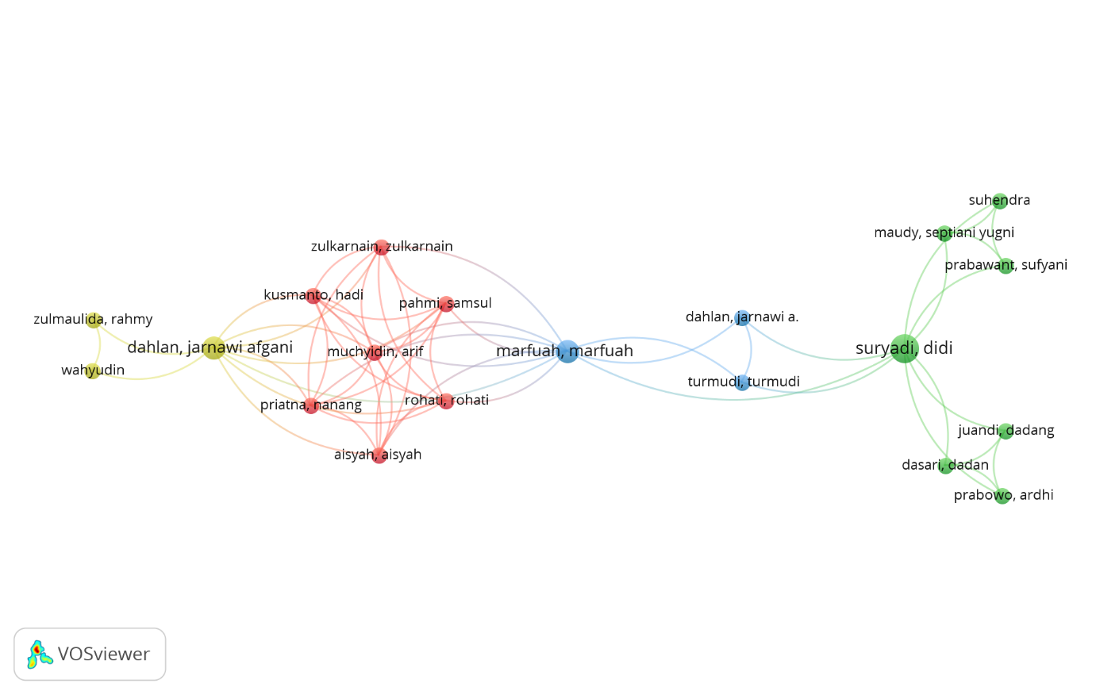
Figure 9. network visualization in author documents, and collaboration between authors

Figure 9 is a visualization of the author's document and the collaboration relationship between authors. There are 108 authors in the metadata. For the same form, it is a collaboration between two authors, such as the red color, which is a collaboration between authors Zulkarnain, Z., and Hadi K. In addition, some authors do not collaborate with others, such as Nasrudin D., Kampa N., and Defrianti D. The top ten authors are displayed in their network, along with their connections. Zulkarnain Z., Rohati R., Aisyah A., Utari S., Saepuzaman D., Yuberti Y., Watanabe g., Munhaz M.G., Rusilowati A., Aminah N.S., Yuliati L.
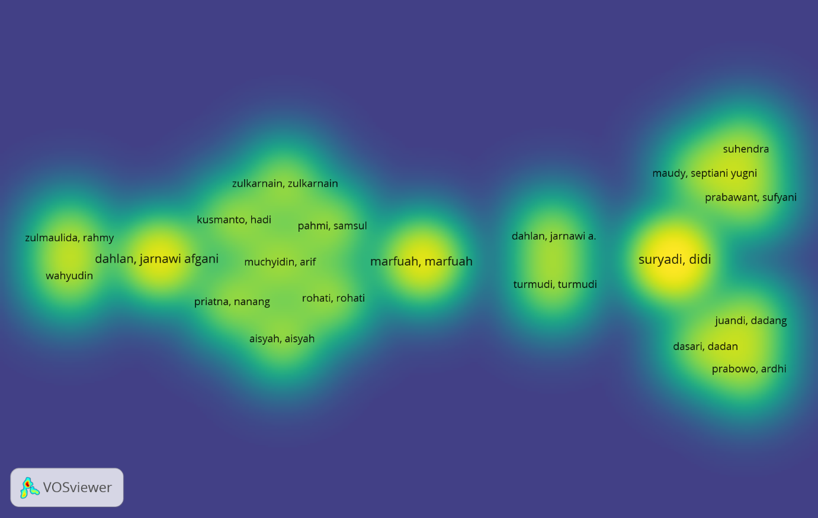
Figure 10. Density visualization of curriculum topic writers in physics learning

The top 10 authors on the topic of Indonesian curriculum in physics on quality and learning outcomes. For more details, see Table 1 below.

Table 1. Top 10 writers on the topic of indonesian curriculum in physics learning
Rank | Author | Documents | Citations | Total Link Strength
1 | Didi S. | 4 | 11 | 184
2 | Marfu’ah M. | 3 | 5 | 102
3 | Afgani D.J. | 4 | 26 | 85
4 | Arif M. | 4 | 34 | 66
5 | Nanang P. | 3 | 24 | 61
6 | Dadang J. | 3 | 0 | 57
7 | Ardhi P. | 3 | 0 | 57
8 | Hadi K. | 4 | 14 | 25
9 | Dadan D. | 3 | 51 | 14
10 | Suhendra | 3 | 18 | 5

Journal Publication Origin
Viewed from VOSviewer, one can also observe the publication of journals from the documentation in the observed metadata database. According to the Scopus database, this study encompasses 110 listed journals. For visualization of the journal, data can be seen in the following image.

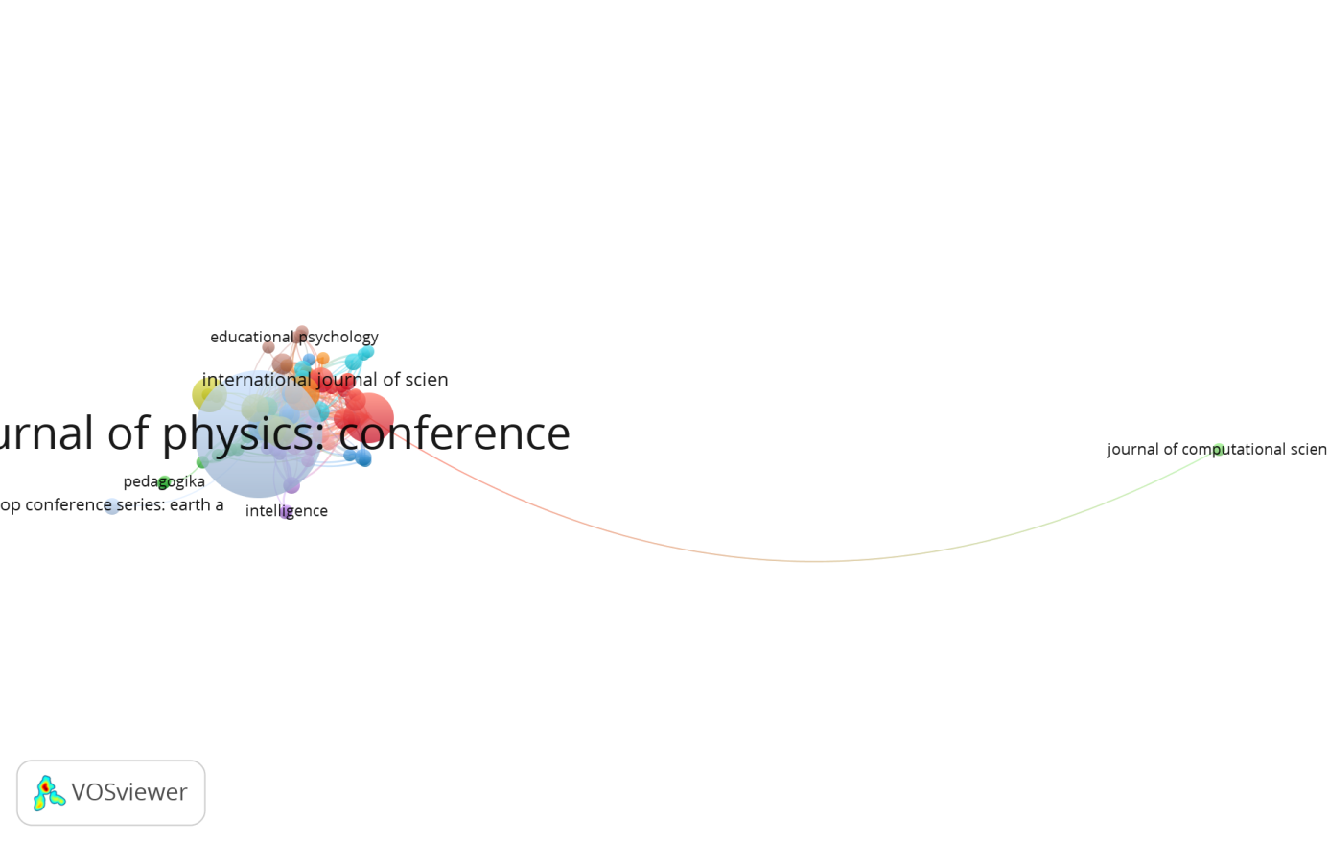
Figure 11. Visualization of journal publication origin

Additionally, VOSviewer can centralize as much journal data as desired. Here, the researcher centralizes the data from 5 journals (top 5), as shown in Figure 11 below.

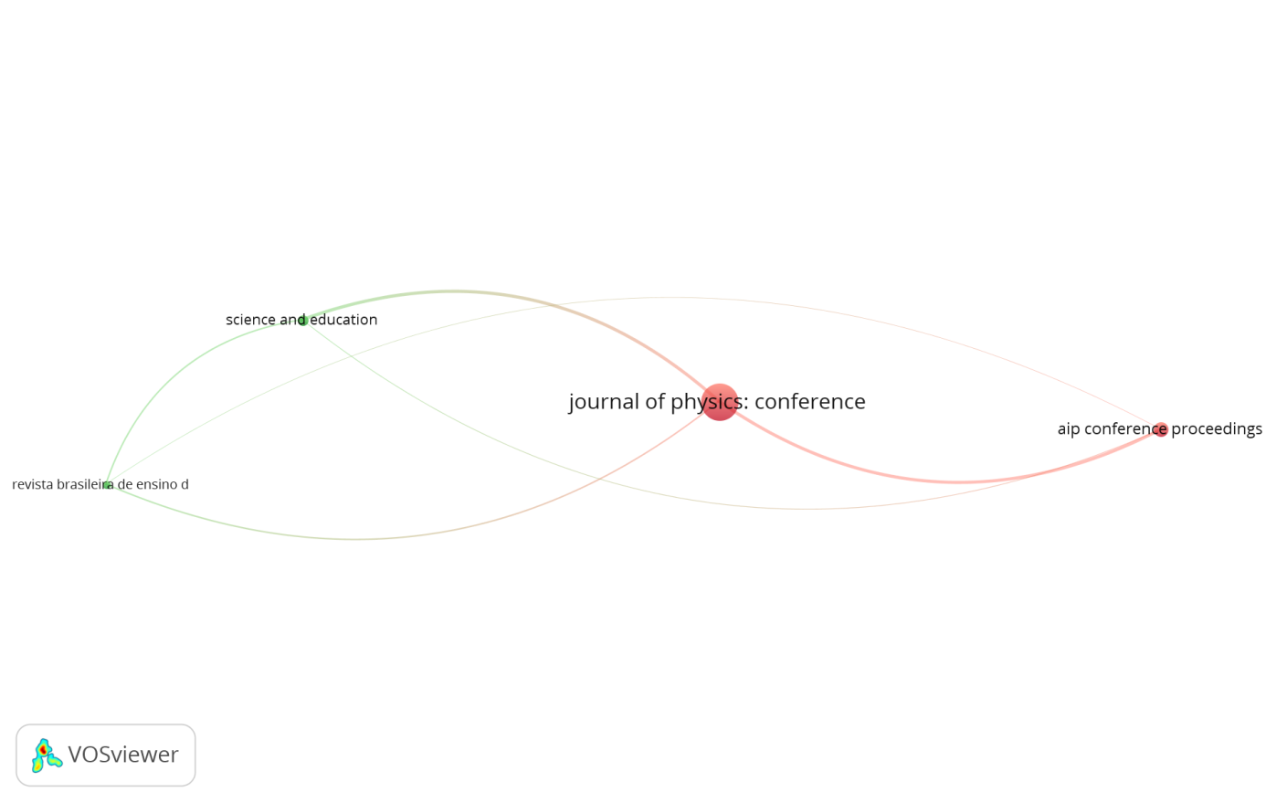
Figure 12. Visualization of top 5 journal publication origins

Based on the number of publications conducted by researchers, it can be seen where the publication journals came from. The following table (Table 2) presents the Top 5 sources or origins of journals that have published the most articles in the field of Indonesian curriculum from 1977 to 2024.

Table 2. Top 5 number of publications by journal
Asal Jurnal | Documents | Citations | Total Link Strength
Journal Of Physics; Conference Series | 102 | 271 | 66
Science and Education | 8 | 63 | 39
Aip Conference Proceeding | 16 | 7 | 32
Revista Brasileira de Ensino de Fisica | 6 | 2 | 15
Physics Teacher | 8 | 30 | 0

Table 2 presents the origin of journals that have published the most significant number of articles in the field of Indonesian curriculum from 1977 to 2024. These data can serve as a reference source for finding literature sources related to the curriculum focus in physics education. This can make it easier for future researchers to locate references and access the latest research being conducted.

Implications of Research Results for the Curriculum in Indonesia
Research on trends, methods, and perspectives of the education curriculum in Indonesia regarding the quality and learning outcomes of physics using a bibliometric approach has broad implications. This study has the potential to map the evolution of the physics curriculum, evaluate its effectiveness, and identify key factors that influence student learning outcomes. Thus, this study can provide more targeted policy recommendations to improve the quality of physics education in Indonesia. In addition, the results of this study can serve as a basis for further, more specific research, such as analyzing the influence of the curriculum on student learning interests or its impact on educational equity. Overall, this study contributes to efforts to enhance the quality of education in Indonesia by providing a deeper understanding of the relationship between the curriculum and student learning outcomes in physics subjects.

Recommendations for Policy Makers and Educators
The recommendations of this research emphasize the importance of periodic curriculum evaluation, research-based curriculum development, and improving teacher quality. For policymakers policymakers, it is recommended to integrate technology into into learning and collaborate with universities in curriculum development. Meanwhile, educators need to thoroughly master the curriculum, apply a variety of learning methods, and develop creative teaching materials. Focusing on developing 21st-century skills and connecting physics to everyday life are also important points in this recommendation. Thus, it is hoped that the quality of physics education in Indonesia can be significantly improved, producing graduates who not only master physics concepts but also have relevant skills to face future challenges.

Discussion
The findings of this bibliometric study highlight the progressive development and diversification of curriculum research in Indonesian physics education from 1977 to 2024. The increasing trend in publications, particularly evident in 2019 and 2021, suggests a growing scholarly interest in curriculum-related issues and their correlation with quality education and learning outcomes in physics (Yenny, 2021).
From the keyword co-occurrence analysis, terms such as curriculum, quality education, curriculum development, and curriculum evaluation were the most prominent. These findings reinforce the previous literature, which emphasizes the centrality of curriculum design in improving learning quality and educational outcomes (Malik et al., 2015; Suhendi et al., 2018; Astalini et al., 2020). The curriculum serves as the backbone of education, requiring constant evolution to respond to societal, technological, and scientific advancements (Ariyani et al., 2018; Setiawan, 2017). The clustering of keywords also reflects diverse research directions, including motivation in learning, curriculum innovation, the integration of science literacy, and independent learning models. For example, the emergence of terms like scientific literacy, test, and independent learning curriculum signifies a pedagogical shift from rote learning to a more competency-based and student-centered approach (Malik et al., 2015; Dewi, 2013).
Furthermore, visualization data using VOSviewer illustrates strong linkages among curriculum development and evaluation efforts, aligning with past studies that recommend continuous curriculum improvement and adaptation as essential to meeting 21st-century educational goals (Handriani et al., 2017; Ahmad, 2020). These interlinkages not only reveal thematic richness but also indicate areas where empirical validation is needed, such as curriculum effectiveness, teacher readiness, and the integration of digital tools in instruction.
The dominance of authors like Didi S. and journal outlets such as the Journal of Physics: Conference Series indicates focal points for collaborative networks and preferred publication platforms, suggesting opportunities for new researchers to engage with established communities and broaden the discourse (Prahani et al., 2022). Overall, this bibliometric analysis demonstrates how Indonesian physics education research has evolved to address not only content mastery but also critical skills, assessment methods, and curriculum adaptability. However, the current literature appears to underrepresent topics like local wisdom integration, inclusive curriculum models, and interdisciplinary linkages—all of which are promising future research trajectories. Thus, the present study provides a comprehensive overview and invites further scholarly exploration to deepen our understanding of the impacts of curriculum, especially in ensuring equitable and high-quality physics education across Indonesia.

CONCLUSION

Fundamental Finding: This study reveals that the trend of research on the Indonesian physics education curriculum has consistently increased over the years, with 287 articles published from 1977 to 2024. The most dominant keywords curriculum, quality education, curriculum development, and curriculum evaluation highlight the central role of curriculum components in shaping the quality and learning outcomes in physics education. The most active contributor in this research domain is Didi S., while the Journal of Physics: Conference Series is the primary outlet for publication in this field. Implication: The findings underscore the importance of curriculum research as a foundation for improving educational quality in physics. The frequent emergence of keywords related to evaluation and development indicates a sustained scholarly focus on refining curriculum frameworks. This suggests that continuous curriculum development is crucial for advancing educational outcomes and adapting to shifting educational demands in Indonesia. Limitation: This study is limited to bibliometric data sourced exclusively from the Scopus database, which may not cover all relevant research published in national or non-indexed journals. Furthermore, the analysis primarily focuses on keyword trends and publication metrics without delving deeply into the thematic content or pedagogical impacts of the individual studies reviewed. Future Research: Future studies could conduct a more in-depth analysis of individual publications to identify specific gaps in curriculum design and implementation. Additionally, integrating local wisdom, interdisciplinary approaches, or digital tools in physics curriculum research may present novel pathways. Expanding bibliometric analysis to other databases and including qualitative assessments will enrich the understanding of Indonesia’s curriculum development trends and needs.

ACKNOWLEDGEMENTS
The authors would like to express their sincere gratitude to Universitas Negeri Surabaya for the support and facilities provided throughout the completion of this research. Special thanks are also extended to the research and publication team, including the library staff and academic advisors, for their assistance in accessing the Scopus database and using bibliometric tools such as VOSviewer. We are also grateful for the collaboration with the University of Wollongong, Australia, for providing academic insights and encouraging cross-institutional discourse. Lastly, we express our sincere appreciation to all peer reviewers for their valuable suggestions, which significantly contributed to the improvement of this paper's quality.

REFERENCES
Anwar, R. (2014). Hal-Hal yang mendasari penerapan kurikulum 2013. Humaniora, 5(1), 97-106. https://doi.org/10.21512/humaniora.v5i1.2987
Ardianto, D., & Rubini, B. (2016). Perbandingan literasi ilmiah peserta didik pada IPA terpadu pembelajaran melalui model guided discovery dan problem based learning. Jurnal Pendidikan IPA Indonesia, 5(1), 31–37. https://doi.org/10.15294/jpii.v5i1.5786
Ariyani, F., Nayana, T., Saregar, A., Yuberti, Y., & Pricilia, A. (2018). Development of photonovela with character education: As an alternative of physics learning media. Jurnal Ilmiah Pendidikan Fisika Al-Biruni, 7(2), 227–237. https://doi.org/10.24042/jipfalbiruni.v7i2.3072
Calista. (2019). Pelaksanaan penilaian autentik kurikulum 2013 pada pembelajaran tematik tema sumber nergi kelas III di MI Negeri 1 Yogyakarta. MODELING: Jurnal Program Studi PGMI, 6(2), 196–203. https://doi.org/10.69896/modeling.v6i2.450
Christensen, J. H., Bønnelycke, J., Mygind, L., & Bentsen, P. (2016). Museums and science centres for health: From scientific literacy to health promotion. Museum Management and Curatorship, 31(1), 17-47. https://doi.org/10.1080/09647775.2015.1110710
Deta, U. A., Suparmi, & Widha, S. (2013). Pengaruh metode inkuiri terbimbing dan proyek, kreativitas, serta keterampilan proses sains terhadap prestasi belajar peserta didik. Jurnal Pendidikan Fisika Indonesia, 9(1), 28-34. https://doi.org/10.15294/jpfi.v9i1.2577
Deta, U. A., & Suprapto, N. (2012). Pembelajaran fisika model diskusi ditinjau dari kecerdasan intrapersonal peserta didik. Jurnal Penelitian Fisika Dan Aplikasinya (JPFA), 2(1), 30-36. https://doi.org/10.26740/jpfa.v2n1
Fitriana, Lesmanawati, L. I., & Maknun, D. (2014). Penerapan pembelajaran berbasis inquiry sederhana untuk meningkatkan literasi sains peserta didik pada konsep ekosistem di kelas X MA Khas Kempek Cirebon. J. Tadris Biologi, 3(1), 21–34. https://doi.org/10.24235/sc.educatia.v3i1.555
Handriani, L. S., Harjono, A., & Doyan, A. (2017). Pengaruh model pembelajaran inkuiri terstruktur dengan pendekatan saintifik terhadap kemampuan berpikir kritis dan hasil belajar fisika peserta didik. Jurnal Pendidikan Fisika Dan Teknologi, 1(3), 210-214. https://doi.org/10.29303/jpft.v1i3.261
Hanna, D., Sutarto, & Harijanto, A. (2016). Model pembelajaran tema konsep disertai media gambar pada pembelajaran fisika Di SMA. Jurnal Pembelajaran Fisika, 5(1), 23–29. Accessed from https://jurnal.unej.ac.id/index.php/JPF/article/view/3558
Hidayati, N., & Idris, T. (2017). Korelasi dan kontribusi asesmen portofolio terhadap habits of mind Peserta didik SMAN Kota Pekanbaru. Jurnal Bioterdidik Wahana Ekspresi Ilmiah, 5(5), 1-8.
Kane, S. N., Mishra, A., & Dutta, A. K. (2016). Preface: International Conference on Recent Trends in Physics (ICRTP 2016). Journal of Physics: Conference Series, 011001. https://doi.org/10.1088/1742-6596/755/1/011001
Krasnova, L., & Shurygin, V. (2019). Blended learning of physics in the context of the professional development of teachers. International Journal of Emerging Technologies in Learning, 14(23), 17–32. https://doi.org/10.3991/ijet.v14i23.11084
Kulakli, A., & Osmanaj, V. (2020). Global research on big data in relation with Artificial Intelligence (A bibliometric Study: 2008-2019). International Journal of Online and Biomedical Engineering, 16(2), 31-46. https://doi.org/10.3991/ijoe.v16i02.12617
Lu, Y., Huang, M., Shi, X., & Chen, B. (2021). Bibliometric and visualization analysis of breast cancer stem cell literature from 2011 to 2020 based on web of science database. Chinese Journal of Tissue Engineering Research, 25(25), 4001-4008. https://doi.org/10.12307/2021.011
Lestari, N. N. S. (2011). Pengaruh model pembelajaran berbasis masalah (ProblemBased Learning) dan motivasi belajar terhadap prestasi belajar fisika bagi peserta didik kelas VII SMP. Journal Education, 1(1), 1–21. https://doi.org/10.23887/jtpi.v1i2.297
Medriati, R., & Risdianto, E. (2020). Penerapan asesmen representasi melalui pendekatan Student Centered Learning (SCL) untuk meningkatkan penguasaan konsep dan kemampuan psikomotor. Jurnal Kumparan Fisika, 3(3), 215–222. https://doi.org/10.33369/jkf.3.3.215-222
Prasetya, C., Gani, A., & Sulastri, S. (2019). Pengembangan lembar kerja peserta didik berbasis inkuiri terbimbing pada materi hidrolisis garam untuk meningkatkan literasi sains. J. Pendidik Sains Indonesia, 72, 34–41.
Purwani LD, Sudargo F and Surakusumah W 2018 Analisis kemampuan literasi sains peserta didik melalui tes socio-scientific issue topik biodiversitas. Journal of Physics: Conf. Seri, 1013(1), 012019. https://doi.org/10.1088/1742-6596/1013/1/012019
Putra, D. S., & Wiza, O. H. (2019). Analisis sikap peserta didik terhadap mata pelajaran fisika di SMA Ferdy Ferry Putra Kota Jambi. UPEJ Unnes Physics Education Journal, 8(3), 299-311. https://doi.org/10.15294/upej.v8i3.35631
Prahani, B. K., Bin Amiruddin, M. Z., Jatmiko, B., Suprapto, N., & Amelia, T. (2022). Top 100 Cited Publications for The Last Thirty Years in Digital Learning and Mobile Learning. International Journal of Interactive Mobile Technologies, 16(8), 18-33. https://doi.org/10.3991/ijim.v16i08.29803
Rahmawati, D., Wahyuni, S., & Yushardi. (2017). Pengembangan media pembelajaran flipbook pada materi gerak benda di Smp. Jurnal Pembelajaran Fisika, 6(4), 326– 332. https://doi.org/10.19184/jpf.v6i4.6213
Santyasa, I. W., Rapi, N. K., & Sara, I. W. W. (2020). Project based learning and academic procrastination of students in learning physics. International Journal of Instruction, 13(1), 489–508. https://doi.org/10.29333/iji.2020.13132a
Suprapto, N., Kusnanik, N. W., Iriani, S. S., Wibawa, S. C., Sujarwanto, S., Yulianto, B., Suprapto, S., Hariyanto, A., & Nurhasan, N. (2021). The comparison of Scimago Institutions Rankings (SIR), Scopus, and SINTA profile: A case of the top Indonesian Institutions. Library Philosophy and Practice (e-journal), 5788, 1-11. https://digitalcommons.unl.edu/libphilprac
Xie, L., Chen, Z., Wang, H., Zheng, C., and Jiang, J. (2020). Bibliometric and visualized analysis of scientific publications on atlantoaxial spine surgery based on web of science and VOSViewer. World Neurosurgery, 137, 435-442. https://doi.org/10.1016/j.wneu.2020.01.171
Xuan X, Jin Q, Jo I, Duan Y dan Kim M. 2019. Potensi kontribusi kurikulum geografi terhadap literasi ilmiah. J. Geog, 118. 5185-196. https://doi.org/10.1155/2019/5185196
Yenny, Y. (2021). Dampak pandemi coronavirus disease 2019 terhadap kualitas publikasi ilmiah. Jurnal Biomedika dan Kesehatan, 4(1), 1-4. https://doi.org/10.18051/JBiomedKes.2021.v4.1-4
Yulkifli, Jaafar, R., & Resnita, L. (2020). Developing student worksheets using inquiry - based learning model with scientific approach to improve tenth grade students physics competence. Jurnal Penelitian Fisika dan Aplikasinya (JPFA), 10(01), 56– 70. https://doi.org/10.26740/jpfa.v101.p56

*Hanan Zaki Alhusni, S.Pd. (Corresponding Author)
Universitas Negeri Surabaya
Jl. Ketintang, Ketintang, Kec. Gayungan, Surabaya, Jawa Timur 60231
Email: hanan.20068@mhs.unesa.ac.id

Akhmad Ismawardani, S.Pd.
Universitas Negeri Surabaya
Jl. Ketintang, Ketintang, Kec. Gayungan, Surabaya, Jawa Timur 60231
Email: 24031635003@mhs.unesa.ac.id

Dr. Titin Sunarti, M.Si.
Universitas Negeri Surabaya
Jl. Ketintang, Ketintang, Kec. Gayungan, Surabaya, Jawa Timur 60231
Email: titinsunarti@unesa.ac.id

Hanandita Veda Saphira, S.Pd.
Digital Technologies for Learning, Faculty of Arts, Social Science and Humanities,
University of Wollongong, Wollongong, Australia,
Northfields Ave Wollongong, NSW 2522 Australia
Email: hanandita.saphira346@uowmail.edu.au

Muhammed Akif Kurtuluş, Ph.D.
Alanya Alaaddin Keykubat Üniversitesi, Turkey
Kestel Neighbourhood University Street No. 80 Alanya Antalya/Turkey
Email: muhammed.kurtulus@alanya.ac.trk

